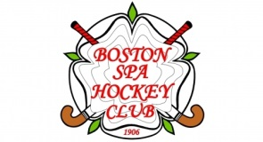
Boston Spa Hockey Club Members Own Insurance Cover – Recommendations

BSHC strongly advises our members to consider taking out their own Personal Accident insurance to cover temporary loss of earnings, death or disablement.
BSHC would also advise members to check that they are covered for loss of their personal hockey equipment, or equipment in their custody and belonging to the Club. These are often covered under their household policy.
BSHC recommend that umpires and coaches, who are asked to operate for teams not part of BSHC, should, before accepting the appointment confirm whether the teams/clubs asking for their participation have suitable Public Liability insurance cover for them in place.
BSHC members who umpire and are on the England Hockey Level One Register (ie have a Registration Number received through satisfactory completion of the EH Level One Umpiring Course) are covered through annual YHA Affiliation fees paid by SHC, when umpiring any match involving BSHC teams at any venue. This insurance does not provide cover when umpiring matches involving non-SHC teams.
BSHC also suggest that if qualified, umpires should consider taking out YHUA (Yorkshire Hockey Umpires Association) membership. (Currently £12 p.a.) Umpires who are members of YHUA and on their ‘Active List’ are covered for umpiring in all games in the UK in addition to receiving updated news and a rulebook.
England Hockey also offers full cover for umpires & coaches within the Gold package of the new EH membership scheme.

